N+ Network Security
Troubleshooting Tools
1. Open the command prompt and use the ipconfig tool to find your computer's IPv4 address and default gateway, then take a screenshot of the output.
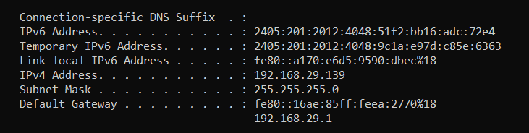
2. Use the ping command to check the connectivity between your computer and www.google.com, then note down the average response time shown.
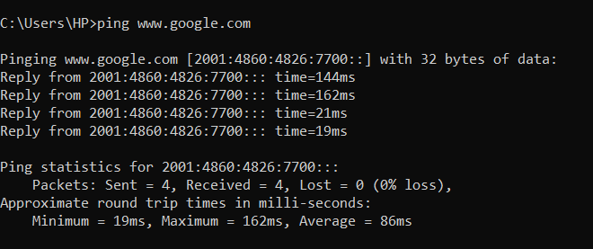
3. Run the tracert (or traceroute on Linux/Mac) command to www.flipkart.com and list the number of hops it takes to reach the destination.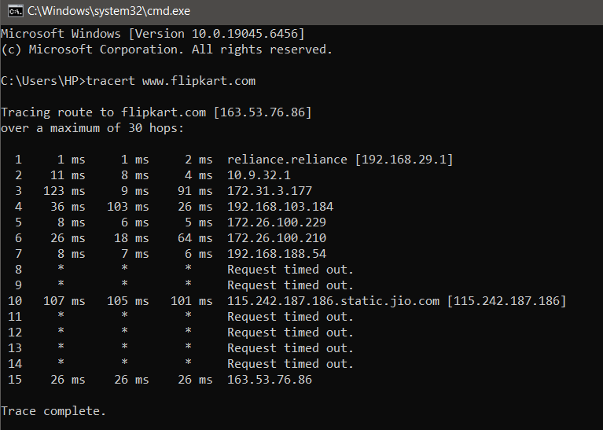
4. Use the nslookup tool to find the IP address of www.spotify.com and explain in one line what this tool helps you verify.
= 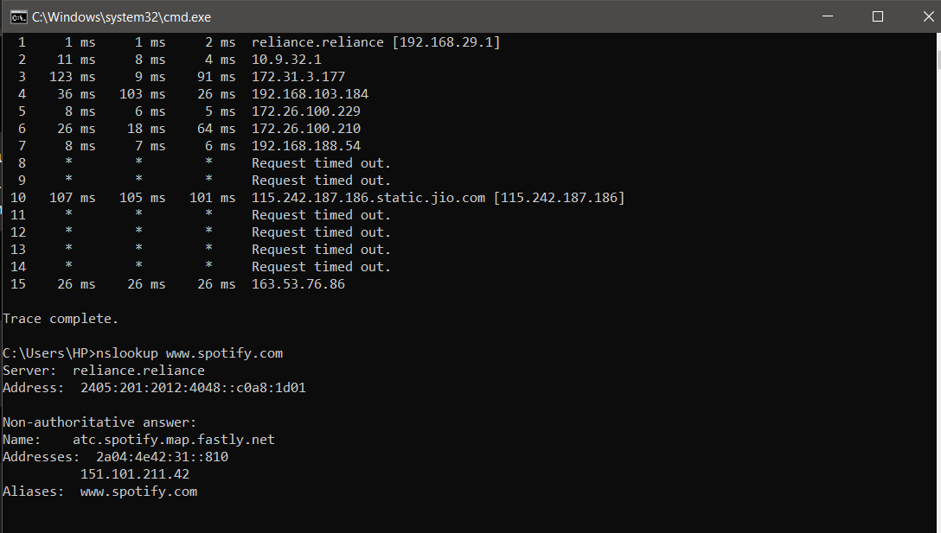
5. A friend says they cannot access Zomato’s website from their laptop. Suggest a sequence of three troubleshooting commands (choose from: ping, ipconfig, tracert, nslookup) you would run to diagnose the issue, and briefly state what each command would help you check.<br><br><em><strong>Hint:</strong> Think about checking both network connectivity and DNS resolution.</em>
=
Command | What it Checks
ipconfig | Checks the computer's IP address and default gateway to verify the network connection.
nslookup www.zomato.com | Checks whether the DNS server can resolve the Zomato website name to an IP address.
ping www.zomato.com | Checks whether the laptop can reach the Zomato server and measures basic network connectivity.

